**Final Report**

This report can help the store with its employee promotion decision, customer behavior analysis, and performance indicators for the near future. The integration of both Python and SQL is used to generate statistical summaries and data visualizations which help us make the final decision in each case.

The store needs to promote one current employee to the manager position. The best fit would be someone who has the overall most experience. Therefore, by analyzing metrics such as how many sales each sales person makes and how much revenue each of them brings we can potentially find the candidate. This process starts with joining the customers, invoices, and employees tables together. From there we group the data by employee and sum up the total transactions for each one of them. The final table output shows that Jane Peacock should be promoted. The result is shown in Appendix 1.

After the promotion, we are interested in knowing how often customers visit the store. We take the data from the invoices table first, group them by customers, sort the invoices by dates and calculate the interval between each visit as frequency. The result of the histogram indicates that the majority of customers will return and purchase the item from our store around every three months or eight months. The result is shown on Appendix 2.

One extra metric that we think will be beneficial to track for the store is the popularity of different music genres. In this case, we can quantity this by measuring the total sales amount for each music genre. We first join invoice_items, tracks, genres, and albums table together. From there we group the new data by genre and sum up each employee’s total sales amount. The result shows that rock is extremely popular being the best selling genre. The second to fourth places are Latin, metal, alternative & punk. Appendix 3.1 shows the result for the most popular genre for top 50 best-selling albums in the store.

Lastly, we need to solve the specific SQL problem on the purchase amount and personal information of those specific customers (ranking 2, 3, 5, 8, or 12). This is done by calculating the total spending for each customer, then ranking them based on their spending and retrieving details of customers who hold specific spending ranks for further analysis or decision-making purposes. Richard Cunningham, Luis Rojas, Julia Barnett, Terhi Hamalainen are ranked from second to fifth in purchasing while Luís Gonçalves, François Tremblay, Bjørn Hansen, Dan Miller, Heather Leacock, and Wyatt Girard tied for twelfth highest on the list. Their name, address, phone, email, total amount, and spending ranks are shown in Appendix 4.

**Appendix**

Appendix 1 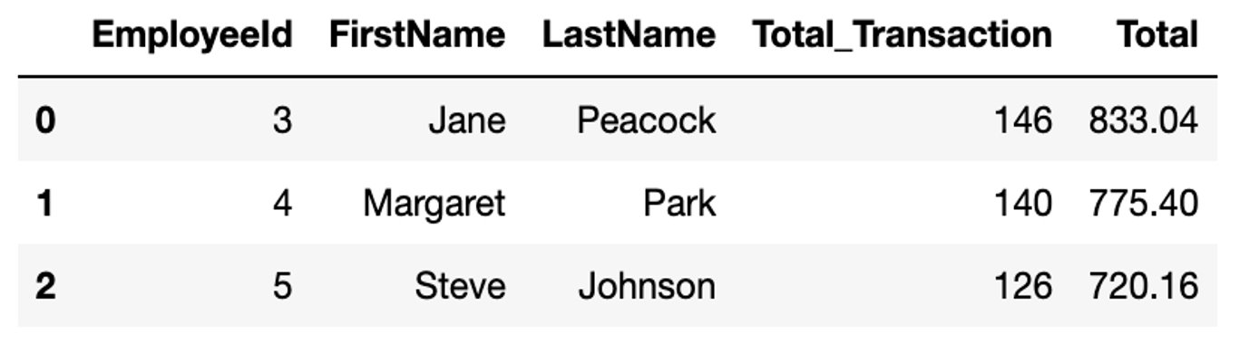

Appendix 2 Visit frequency distribution

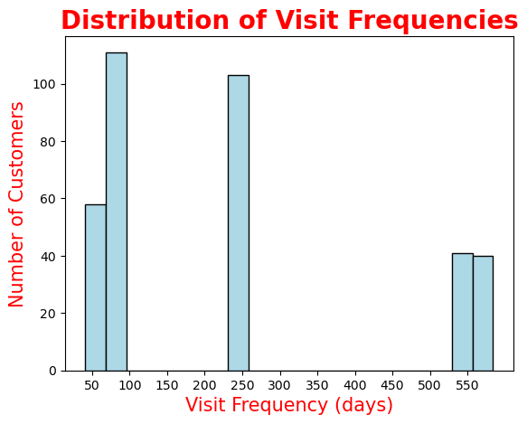

Appendix 3.1 Top 15 best selling albums

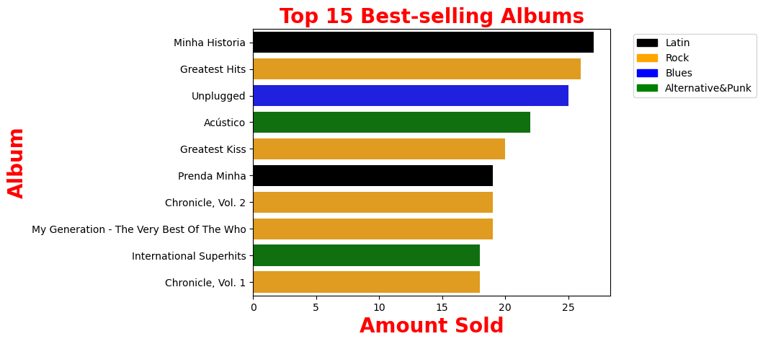

Appendix 3.2 Most popular genre for top 50 best-selling albums

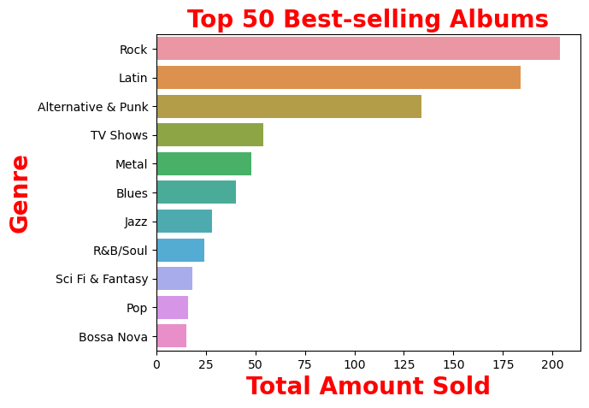

Appendix 4 Customer Spending Rank

